Invoice/Payment Portal Setup
Mytech’s invoice/payment is located at: Mytech.connectboosterportal.com/authentication/login
Invoices from Mytech include a link to this site
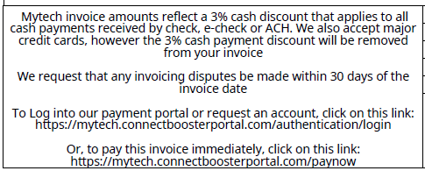
If this is your first time using the Mytech invoice portal, you should have received an email from ar@mytech.com with the subject line “Welcome To Our Mytech Online Invoice and Payment Portal”. Click the Set Password button to set your password.
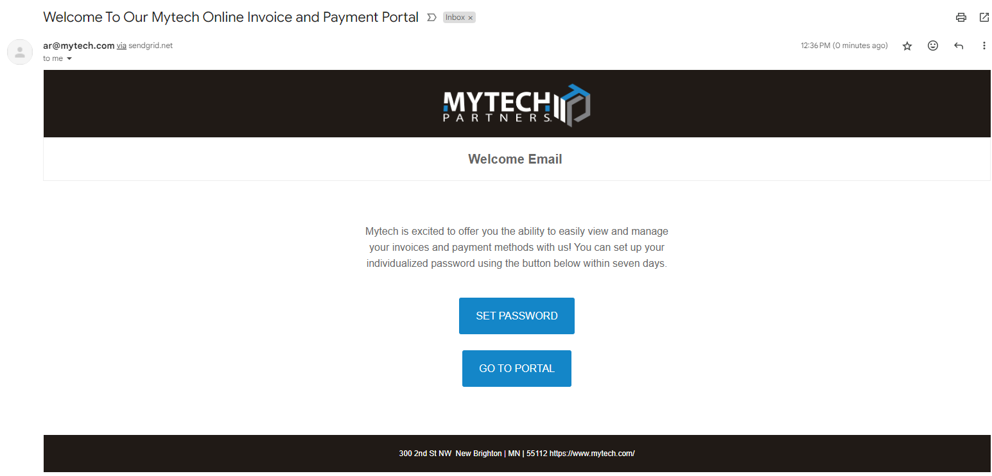

You will receive another message from ar@mytech.com with the subject “Password reset”. You can click “Go to Portal” button to log in
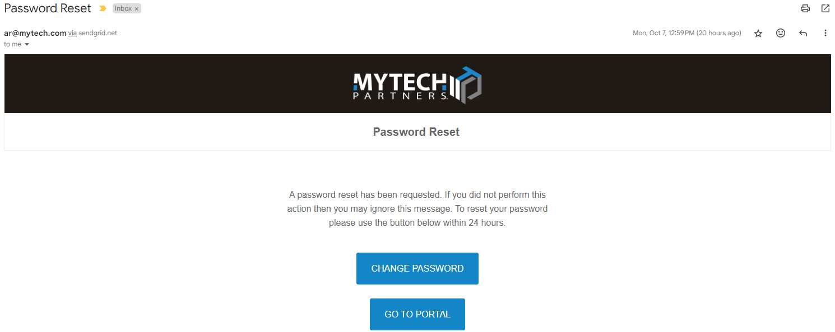

To setup your bank account, click New button in the Payment Methods section.
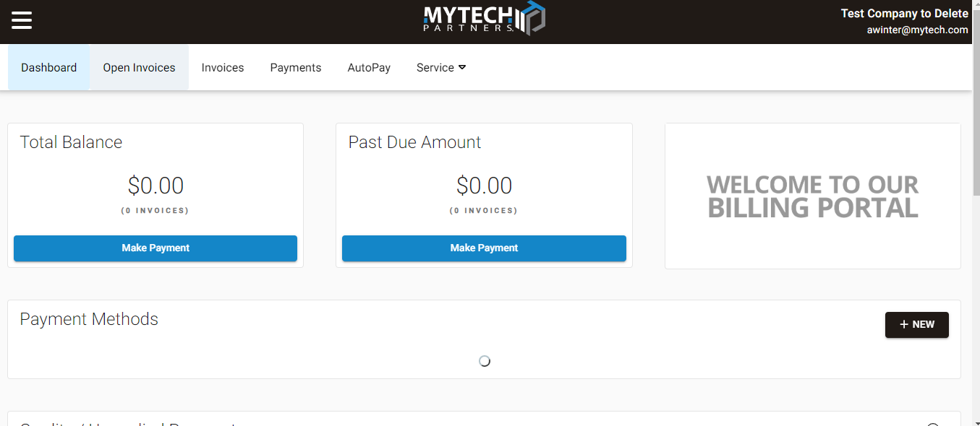

Click Bank Account and enter the data for each of the required fields, being sure to scroll all the way to the bottom. Accept the terms of service and the bottom and click submit
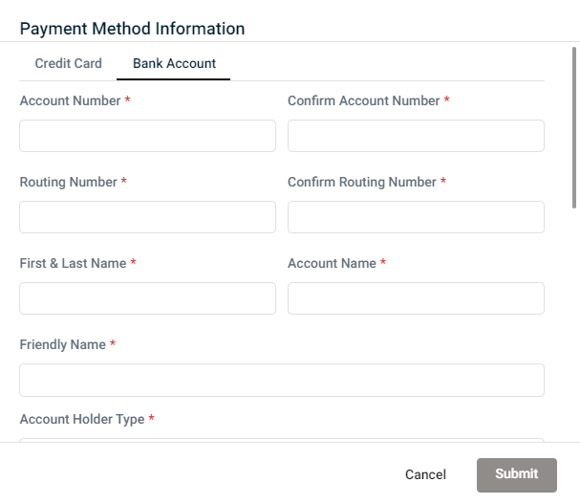

To review an invoice and make payment, navigate to Invoices, then click the invoice number.
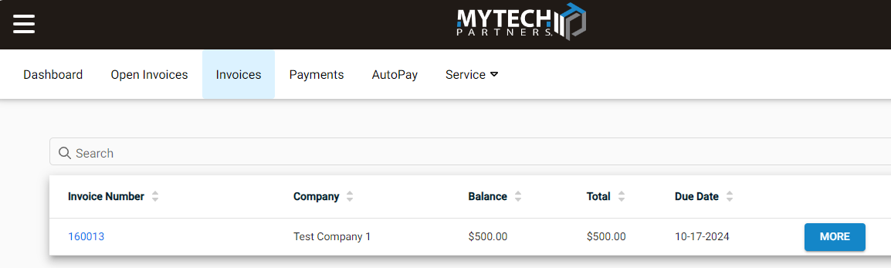

You can view an image of the invoice by clicking View and you can pay by clicking Pay
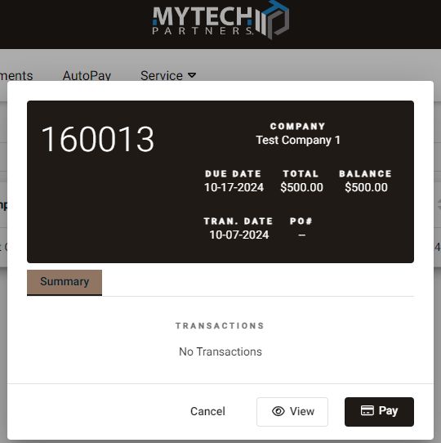

The image of the invoice should be the same as the invoice that was emailed and this opens up in a new window. You can close the new window when you are done viewing it. After you click Pay, you will click the Select Payment Method dropdown, and choose the account you have set up for payments. You have the ability to change the amount, but the default amount will be the total amount due on the invoice. Hitting Next will proceed with the payment today.

You have the ability to schedule the payment in the future. If you want to do this click the button in the Schedule Payment section, then select the date for payment.

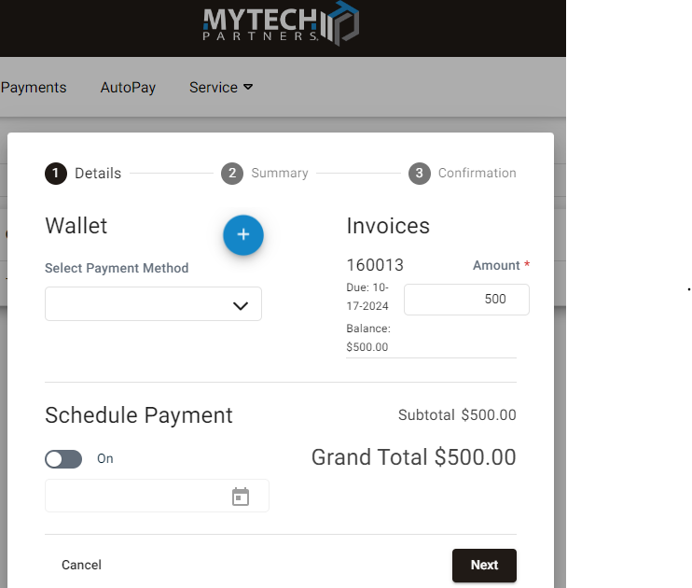

Then just click confirm to submit/schedule your payment.
