Take back your cloud environment | Cleaning up Microsoft Teams and SharePoint sprawl

Slide 5
Prevent team members from creating channels (you need to be a team owner in order to do this)
By default, Microsoft allows anyone to create teams and channels. This can quickly lead to ‘channel sprawl’. When creating a team, it is important to disable these settings.
- Click on the breadcrumbs next to the team’s name
- Click on ‘Manage Team’
- Select ‘Settings’
- Select ‘Member permissions’
- Uncheck the following boxes:
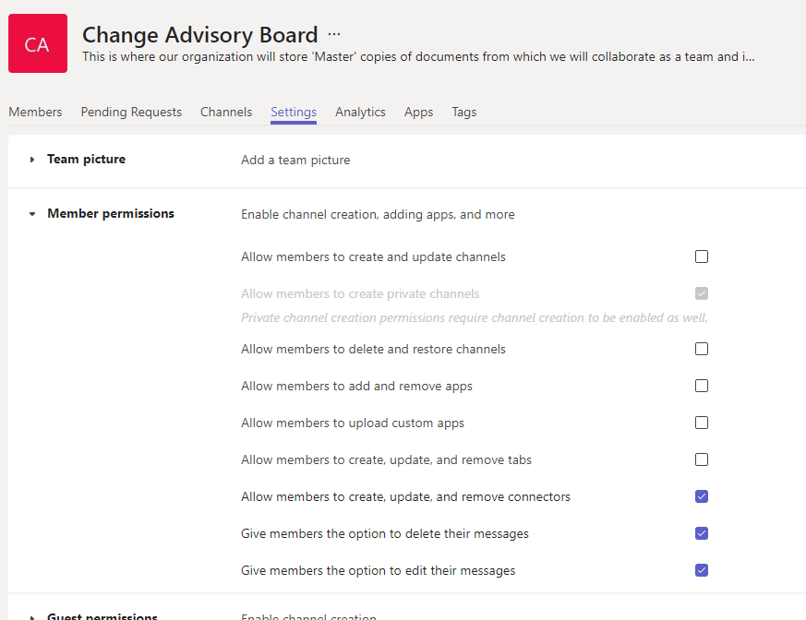

Slide 8
- Review your current teams and channel structure in the Teams Admin center
Note: you’ll need the appropriate Teams administrator or Global administrator permissions to view these reports
  - Open the Teams Admin Center
  - On the left panel, select Manage teams
  - Click on the team you want to view and select ‘Members’ OR click on the ‘Channels’ tab.

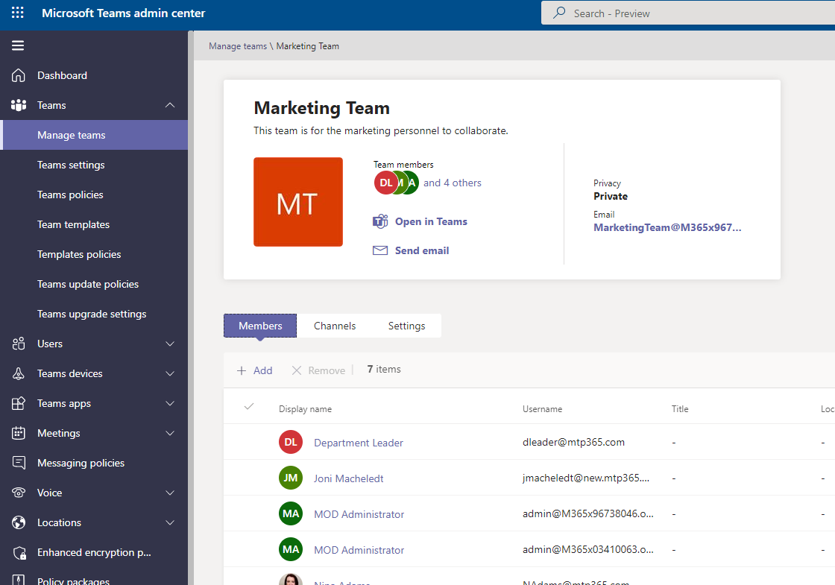

- How to review your MS Teams usage (90 day)
  - Open the Teams Admin Center
  - On the left pane, select Analytics and Reports > Usage reports
  - Teams usage
  - Last 90 days
  - Run report
  - Export to Excel for further analysis
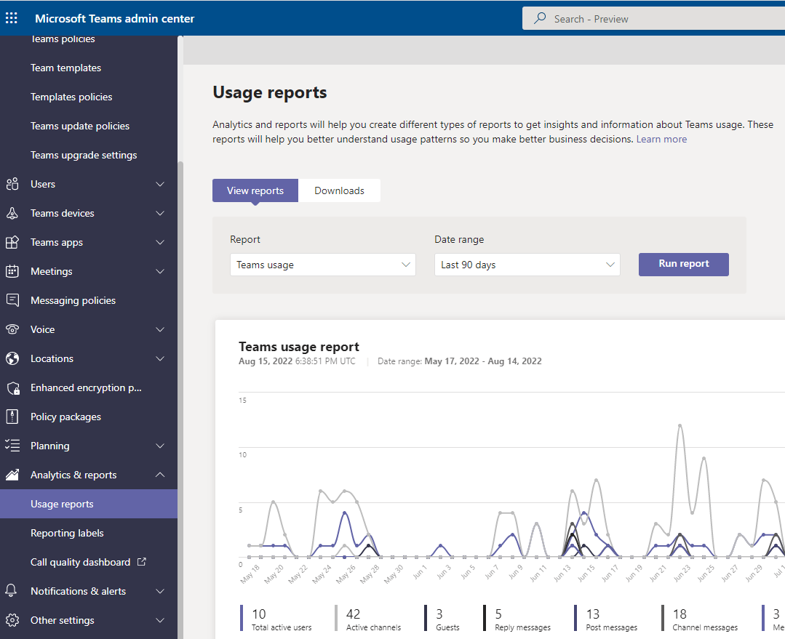

Slide 10
How to view your active SharePoint sites
Note: you will need the appropriate SharePoint administrator or Global administrator privileges to access the admin center.
- Open the SharePoint Admin center
- Select ‘Active Sites’ on the left pane
- Select the ‘Export’ option to view in Excel for further analysis.

