Microsoft Teams & Communication Basics
Microsoft Teams IS NOT just a chat application. Let’s start with understanding the structure of Teams, and how the application will help your organization communicate more effectively.

Chat vs Teams
Although both Chat and the Teams section of Microsoft Teams, help you communicate with one another, it’s important to understand the differences when choosing how to collaborate.

Microsoft Teams CHAT:
- Chat or Group Chat is similar to Text Messaging
- Renaming Group Chats
- Pinning Chats
- Reply to a Chat

Microsoft TEAMS
- Conversation Threads
- Use the ‘Format’ icon
- @Tag Team or Team Members
- Things to think about

Outlook & Teams
Business Professionals are very comfortable with using Outlook & Email, now an additional communication method is being introduced with Teams that can cause frustration with another application to check for communicating.

Share Important Messages from Teams to Outlook
Acknowledge and help the transition to leveraging Teams by intentionally sharing important messages from Teams to Outlook.

Share Messages from Outlook into Teams
Outlook provides the ability to share emails into Teams, and to quickly chat with an internal email sender. Leveraging this capability, you can drive more internal communication into Teams.

*NOTE – We recommend as an organization that you be prescriptive. For Example, use Outlook for external communication, but all internal communication goes through Teams. It’s good for an organization to have a communication policy that defines communication preferences. If we are all using Teams in the same way, it helps to drive adoption.
Sample Communication Policy in Appendix A

Notes:

Scheduling Meetings
Department Meetings, Vendor & Client Meetings, Internal Ad-hoc meetings – these meetings can be scheduled via Outlook and Teams – which method makes the most sense and why is important to understand.

Outlook Scheduled Teams Meetings
These meetings are best for external meetings and ad-hoc internal meetings. When these meetings are held, they are essentially creating a Group Chat Call so any messaging and file sharing in the meeting will be captured in the Teams Chat Section of Teams.

Teams Scheduled Teams Meetings
These are best for Department Meetings, All Company Meetings, & Team Training Sessions. When you schedule from Teams (the respective Teams Channel or Teams Calendar) there is an option to host the meeting IN a Teams Channel. When messaging and any file sharing or recording occurs in these types of meetings they fall within the Team and Channel where they are hosted.

Outlook Calendar Meeting Defaults
Helping your team set up their Outlook Calendar meeting defaults can go a long way to making their lives easier and to make fewer clicks to schedule meetings. Tips will be shared in the session to illustrate how to define your calendar meeting defaults.
Notes:

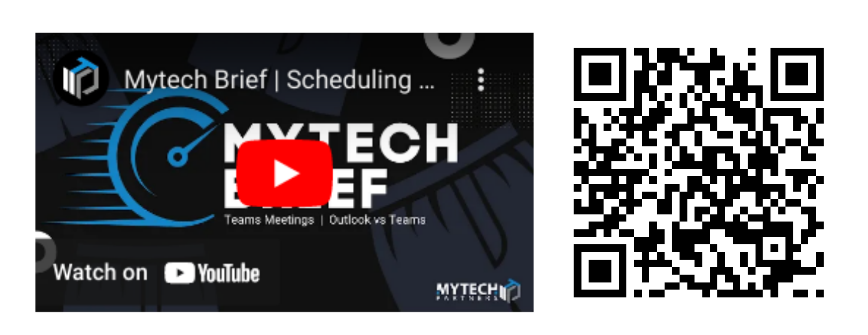

Microsoft Teams & SharePoint Integration
When a ‘Team’ is created, so is the corresponding SharePoint ‘Team’ site. These two Microsoft 365 applications are connected and core to how document collaboration and other capabilities integrate in the M365 platform. A security group is also created when a ‘Team’ is created that connects the permissions between Teams, SharePoint and other M365 applications integrated with Teams.

Owners & Members Have Read/Write Access:
The permissions for a Team, and the corresponding SharePoint site (and other applications that may be integrated into a Team) are all managed within the “Manage Team” capability. This makes delegating the additions or removals of individuals to that Team simple and easy to manage by Team Leaders, Department heads, etc. All Owners and members of Teams have read/write access to all content within the Team.*

Two Types of SharePoint Sites:
Team Site and Communication Site are two types of Sites. While we will not be diving into Communication Sites today, if there are document repositories where you want to restrict access for some individuals to have Read ONLY access and some to have Read/Write access, leveraging a Communication Site is where you will want to look.

Teams is a window into SharePoint:
SharePoint is where everything in M365 is stored. Accessing Files through Teams is merely a window into the SharePoint Document Library.

*Unless a Private or Shared Channel are being leveraged – which is covered on page 8 of this workbook

Document Collaboration
Teams & SharePoint document collaboration capabilities are drastically different from the world of File Servers. There are several variables to keep in mind to successfully collaborate on documents with colleagues – internally or externally.

Multi-User Editing:
No more files locking here! Multiple people can open and actively edit the same document at the same time. For this capability to exist ‘Auto Save’ is always on, which is great until content is overwritten inadvertently. When that happens, you can restore to a previous version using…

Version History:
This capability is very powerful so that you can easily compare different versions of the same document and delete or restore previous versions as needed.

Prescribe How Feedback Is Shared:
When inviting colleagues to provide feedback on a draft document, first determine how that feedback should be shared. For example, should the document be edited; turn on track changes; or leverage the comments feature of documents. Whichever method desired, prescribe the method to use when eliciting feedback for best results.

Combine Teams & SharePoint Capabilities for Optimal Collaboration:
Start a new conversation in Teams to elicit feedback from colleagues to review a document. Leverage the following capabilities to make communication and collaboration more effective.
- @Tag the Team or Individuals from whom feedback is sought
- Link the document in question within the conversation for one-click access
- Leverage comments to collaborate within the document
- Reply within the conversation string to share updates and status of review

OneDrive, OneDrive & OneDrive
Thank you, Microsoft, for naming multiple different functions with the same name. There are three different versions of OneDrive that are important to know they exist and how they should (or should not) be used.

OneDrive – Company Name (with a Cloud Icon):
This OneDrive is essentially the replacement for My Documents or User Drives. This is only accessible by the individual person unless they have intentionally shared documents with others – internally or externally to the company.

Company Name (OneDrive with a Building Icon):
This OneDrive is an indicator that a device is Syncing content from a corporate SharePoint site.

OneDrive – Personal (with a Cloud Icon):
Microsoft provides a free personal OneDrive to anyone who registers for one. The personal OneDrive is can be and often is blocked on corporate devices to ensure that company data is not being stored / saved outside of corporate security and backups.

Managing Sync Settings in OneDrive:
There are three options within OneDrive that inform the Sync Settings that are being employed by any file or folder. These settings are indicated by a cloud (the bits are in the cloud), hollow green circle with a solid checkmark (the bits are cached on the device and will stay in sync with the cloud), or a solid green circle with a hollow checkmark (the bits will always stay on the device and keep in sync with the cloud).

Running Team Meetings & Task Management
Most departments operate with a weekly, bi-weekly, or monthly meeting rhythm. Solving the common problems that exist when running team meetings is a great opportunity to leverage the Microsoft 365 tools (that you are already paying for) and to incrementally drive adoption across your organization.

Meeting Agenda & Minutes:
Having a standard meeting agenda can help keep you organized and enable productive/efficient meetings. Within Teams, leverage OneNote to keep the standing meeting agenda, and specific meeting notes where the entire team will have access to review.

Topic List / Parking Board:
Having a central repository for topics and issues that need to be discussed during team meetings is extremely valuable. Rarely does the time allow for all topics to be discussed in every meeting, and having a central list allows the facilitator to keep track of topics from meeting to meeting, and this allows team members to add/update issues and topics as needed.

Team Action Items:
Keeping track of action items in a consistent manner affords everyone to have complete clarity over what task needs to be completed, by whom and when. This will eliminate excuses and drive accountability. Team visibility creates individual accountability.

Shared Metrics:
Most departments review Key Performance Indicators as part of their standing agenda. This can be enabled with a shared Excel Spreadsheet (with out file locking issues), or through a PowerBI or other dashboard that can be integrated into Teams.

Rate the Meeting:
While this is an optional item to a meeting agenda, the Entrepreneurial Operating System (EOS) defined in the book Traction recommends that you rate the meeting after every meeting. This allows the team to provide feedback on how effective the time was spent and whether or not there are suggestions to improve the impact of the meeting in the future.

Channels / Types
Within a Team – there are three different channel types: Standard, Private and Shared Channels
Why do we need channels?
- When you create a team or group, a default channel is created. This is called the ‘General’ channel.
- This is usually where the bulk of your team conversations, meetings and file collaboration will take place.
- You can, however, create additional channels. This helps to create separate ‘conversations’ or ‘topics’ within the team.
- Caution - Less is more! Be very thoughtful about the ‘why’. OR channel sprawl will become an issue ….. take way more clicks than necessary to get the job done.

Standard Channel
- All Members of Team have Read/Write Access
- Integrate M365 Applications like Planner & Forms

Private Channel
A private channel is different than a standard channel, since it will be hidden from you, unless you’re a member of that channel. NOTE: PRIVATE CHANNEL IS INDICATED WITH A LOCK ICON
- Must be a member of the parent Team to be added to a Private Channel
- By default ‘Members’ can create a Private Channel
- Creates a Separate SharePoint Site
- M365 Application Integration not supported

Shared Channel
A shared channel allows multiple teams/individuals to collaborate with each other without being a member of the parent team.
- Can be added to multiple teams/individuals
- Can be shared between organizations
- Creates a Separate SharePoint Site
- M365 Application Integration not supported

Strategies to Drive Adoption
- Define a vision & organizational goals
- Get executive buy-in/sponsorship
- Establish Organizational Communication Preferences
- Team / Department Activities – should live in Teams
- Identify Adoption team/champions & Train them
- Implement Solutions that have a regular frequency/Occurrence
  - Running Team/Department Meetings
  - Supervisor/Direct Report one-on-one’s
- Adoption plan & future governance and continual improvement
- Celebrate success
- Resources: https://adoption.microsoft.com

Notes:

Microsoft Teams Structure Best Practices
- Mirror your organizational design
- Least teams/channels to get the job done
(fewest clicks)
- Lock down channel creation for members
- Assign Owner & Member Permissions by Team
- Create a ‘one-stop-shop’ inside your team e.g.:
  - Agendas & minutes
  - Task management
  - Parking / Topic / Issue Discussion Board
  - Polls, surveys, requests etc

Teams Structure Planning
Build a table to start thinking through your department and what types of channels you may need?
Team | Channel Name | Channel Type | Owners | Members
Marketing | Events | Standard | All Team Members
 | Budget | Shared | Marketing & Finance

Plan for ongoing adoption and engagement
Identify your team / Who will drive this? | Training / adoption members  Key leaders
Tools to foster training & adoption | SharePoint intranet portal – 365 training resources  MS Forms – training requests  Monthly check-in meetings  Ongoing training sessions (what format will these take?)
Team check-ins / frequency | Monthly / quarterly meetings / Surveys?  Determine ongoing action items re:  What’s working?  What’s not working?  What’s missing?  What’s confusing?
How will success be measured & communicated? | Key metrics (usage, adoption score)  Staff presentations to communicate success
Spreading awareness | Mini events (lunch or breakfast sessions)  Posters  Awards / gift cards based on SharePoint usage reporting stats.  Competitions

Half Day Driving Adoption in Your Organization.
By Mytech Partners
Equip your Microsoft 365 Champions, Evangelists, and Power Users with the tools to drive adoption of the Microsoft 365 Suite of Tools across your organization. After a planning session with your organization, we will deliver a half-day training session with your M365 Champions (those whom you choose to assist in driving adoption).
The session will be held and recorded in a Teams Sandbox established for your team to test, try and learn how to apply the lessons learned in a non-production environment before exposing any change to the rest of your organization.
Deliverables:
- Half-Day Guided Custom Training Session - recorded.
- Driving Adoption Workbook with Tips & Tricks for future application.
- Governance & Adoption Guide to keep the adoption momentum going over time.

$2500 – Half Day Session

Resources
Check out this video that will walk you through step-by-step setting up your own Teams hub for running your department meetings.
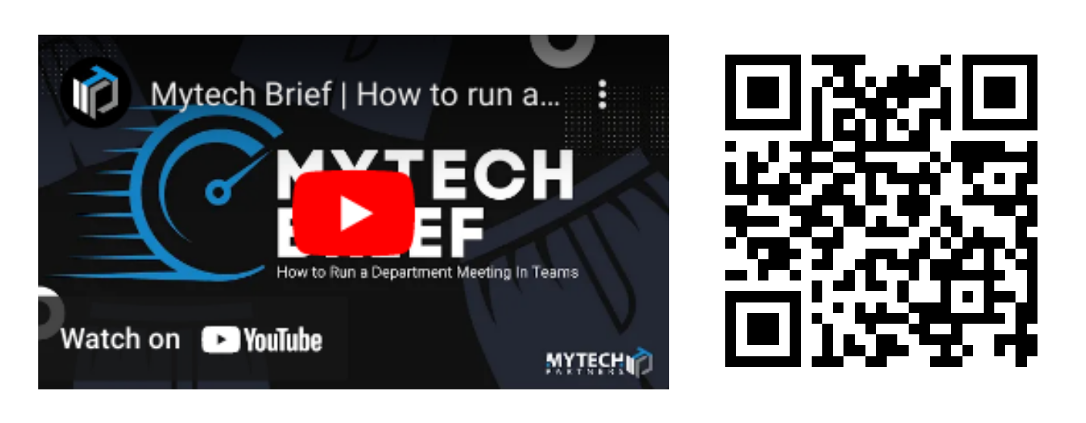

For more information and helpful resources, including a digital copy of this workbook visit www.mytech.com/driving-adoption

Appendix A
Internal Communication Policy - MS Teams
Effective Date: [Insert Date]
We're excited to introduce our new internal communication policy, aimed at fostering stronger connections within our organization. Our goal is to create a standardized approach that enhances collaboration and promotes efficient communication among all team members.
To achieve this, we have chosen MS Teams as our primary communication tool for internal communication and collaboration. We believe that Teams offers a user-friendly platform that streamlines communication and provides numerous benefits. It centralizes all our conversations, ensuring easy access to previous discussions and promoting efficient collaboration.
Moreover, Teams seamlessly integrates with other Microsoft tools such as Outlook, OneDrive, and SharePoint, making file sharing, meeting scheduling, and task management a breeze. Rest assured, Teams prioritizes your privacy and security by employing encryption to safeguard all conversations and data.
While we encourage the use of Teams for internal communication, we understand that there may be specific situations where an alternative method is necessary. However, we kindly request that alternative communication methods be limited, as this helps maintain consistency in our collaboration efforts.
To ensure a smooth transition, we are committed to providing comprehensive training and ongoing support to all team members. We want everyone to feel confident and proficient in utilizing Teams for their daily communication needs.
We firmly believe that consistency in communication is the key to fostering unity, avoiding misunderstandings, and promoting collaboration. By embracing MS Teams as our primary internal communication tool, we are confident that we can achieve these goals and enhance overall efficiency within our organization.
If you have any questions or concerns regarding this policy, please do not hesitate to reach out to [Insert Contact Information]. We are here to support you every step of the way.
Thank you for your cooperation.
Best regards,
[Your Name] [Your Title]

