Change Advisory Board (CAB) Team Guide

Summary:
Our use of Teams gives us a streamlined method for accountable staff of specific tools and areas of the business to manage change and collaborate with others. Integrating Teams with Process and Documentation is a way for us to maintain Security Controls over which processes and documents are in production and accessible to staff. ITIL governance of change and deployment of change is managed through what is called a Change Advisory Board, or CAB for short. This guide will provide the structure and maintenance of our Internal Change Management Methodology at Mytech Partners.

Change Requests
Change Requests will be raised through practice of process and open dialog between staff and management. They will also be raised by our CAB (Change Advisory Board) Leaders and Members.

- Management will be able to submit change requests to the appropriate CAB Team using their Mytech HELP Center. This is a formal request that will raise a service ticket and notify the CAB team channel members they are assigned with the ticket number and summary. We want there to be dialog and understanding of the issue by the manager BEFORE a change request is submitted.
  - It is expected that the managers have ongoing and open dialog with CAB Team Leaders and Members as part of learning and becoming better versed in our toolsets, systems, and processes.

- Team Channel (CAB Members) will be collaborating actively and
  - They may produce updates to master documents
  - They may agree to have a change request submitted for a toolset, i.e., ConnectWise.

The ConnectWise Manage Service Board called “Change Advisory Board” will house the tickets raised by managers or any ticket managed by the CAB team for auditory purposes. When a CAB Team channel has updated their Master Document, they will raise a change request to move that document to the Production Documents folder in SharePoint. These are uneditable copies of the master documents.

What IS a change request?

- We need to change the order of process
- We need to change a document or template
- We need to create new…

What IS NOT a change request?
- The link is broke
- Price is incorrect
- Template misspelled

Documentation

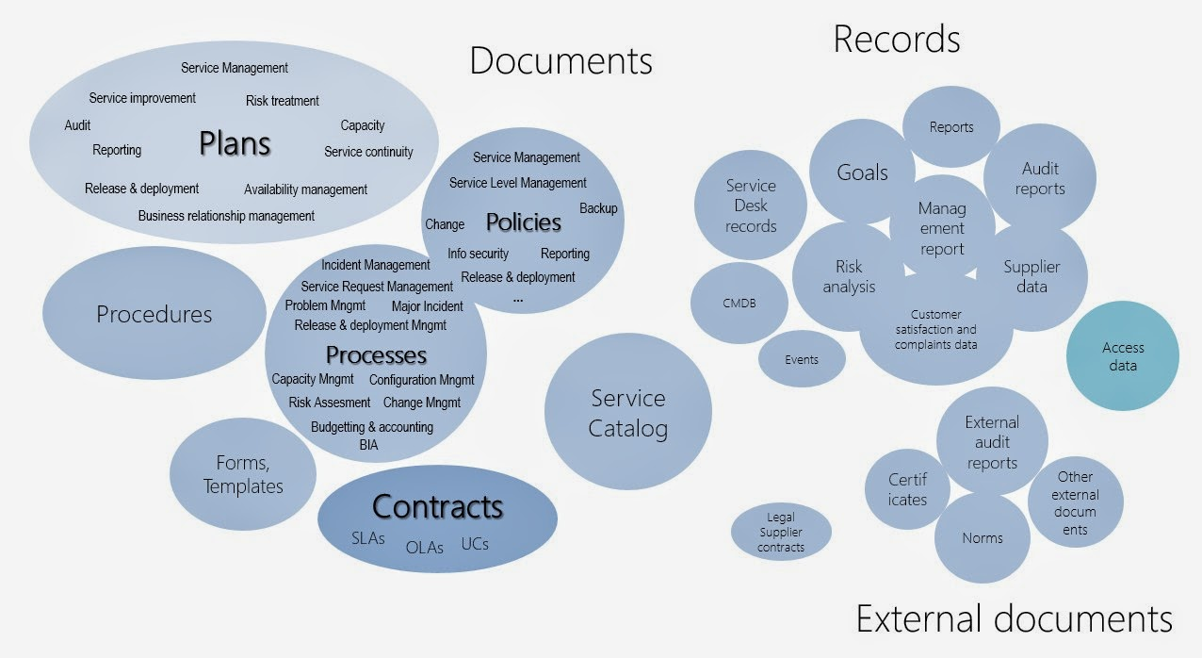

We have documentation used in all our core processes and we have instructions and templates throughout. We need to manage where all these documents live. This is critical for consistency in operations and service delivery. In addition to documents, we often need to collaborate around our tools, systems, and processes to bring change or improvement in a pragmatic way.

When we talk about internal documentation, or our operational instructions, the templates we use to fill in and add client information, ITIL Service Management provides this guidance in reference to internal document management:
What you have to have in mind with these documents is that:
- they must be easily accessed by the authorized personnel,
- they have to be found and identified quickly
- approved by authorized people
- only the last approved version should be accessible to the audience
- versioning might come in handy.
Documentation will be managed in two categories: Master Documentation and Production Documentation. Master Documentation will be the editable and changeable documents that are collaborated on and owned by the CAB team – preferable to have Managers able to join this collaboration.
Production Documentation will be the “live” documentation that is linked and available to all in their respective Teams and on the process site as well.

